Merrill Rudd

May 6, 2016

HW5 – 1D Spatial models

The root mean squared error in estimates of Linf at each site was 0.88 when the spatial trend was incorporated in the model and 0.89 when no spatial trend was considered. However, these results were only from 20 iterations of 1,000 simulated data points (Figure 1). These preliminary results indicate that the difference in the Linf along the coast was not significant enough for the model to separate the spatial trend from the random effect between sites.

As a check, I ran the simulation model with 100 observations, instead of 1,000, and conducted 100 iterations of these 100 observations. The improvement of the use of the model with a spatial trend was slightly clearer with the 100 iterations of simulated data (Figure 2), but more formal model selection should definitely be used to account for variable Linf between sites when modeling growth along the coast.

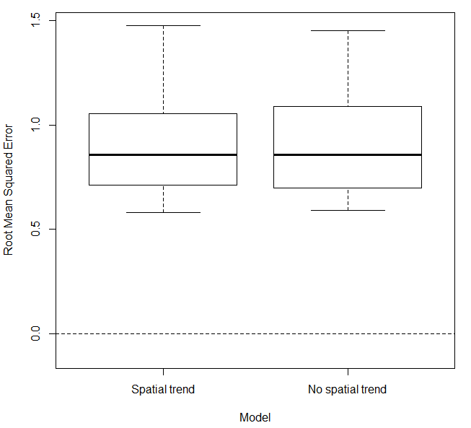

Figure 1. Root mean squared error in the estimates of Linf between models that assume a spatial trend with latitude, and one that does not assume a spatial trend with 1000 age and length composition samples along the coastline, and the simulation iterated 20 times.

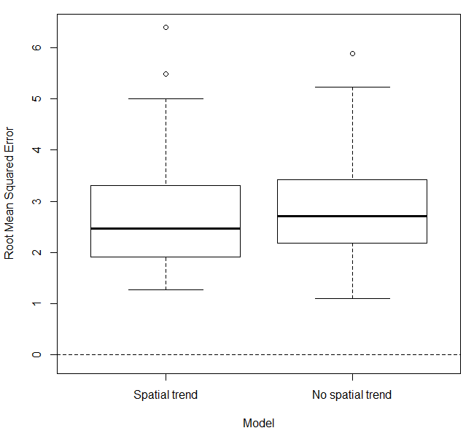

Figure 2. Root mean squared error in the estimates of Linf between models that assume a spatial trend with latitude, and one that does not assume a spatial trend with 100 age and length composition samples along the coastline, and the simulation iterated 100 times.